InnerJoin

1) Display the Cartesian product of the party and candidate table
select * from mendoza_party cross join mendoza_candidate;

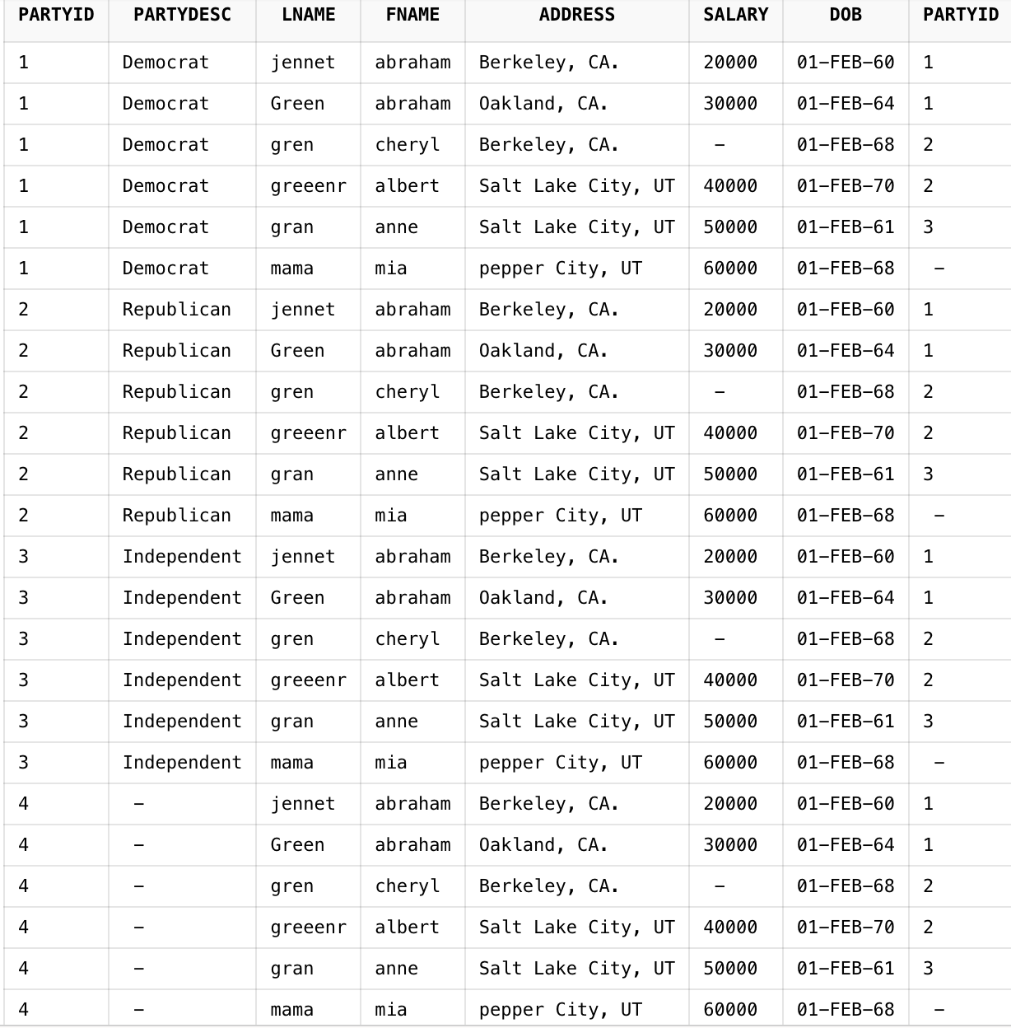

2) Display the lastname and the party description of each individual
-- select c.lname, p.partydesc from mendoza_candidate c inner join mendoza_party p on c.partyid=p.partyid;
-- Or simply...
select lname, partydesc from mendoza_candidate natural join mendoza_party;

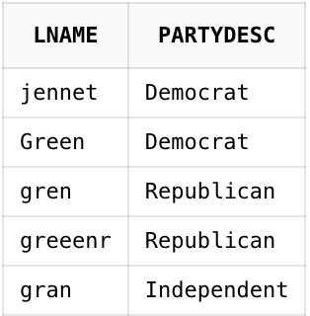
3) Display the last name and the party dscription of each individual. If there is not a party description, then display no description. (Use the NVL function)
select c.lname,NVL(p.partydesc,'No description') from mendoza_candidate c left join mendoza_party p on c.partyid=p.partyid;

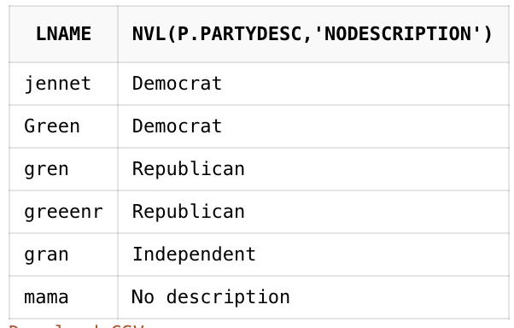
4) Display the number of people in each party (display party_description)
select p.partydesc,count(c.lname) 'Number of people' from mendoza_party p inner join mendoza_candidate c on p.partyid=c.partyid;

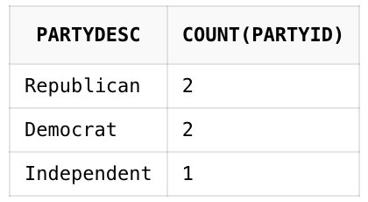

5) Display the number of people in each party for only those parties whose average salary is greater than 50,000. (Identify the party name)
SELECT partydesc, count(partyid) from mendoza_party natural join mendoza_candidate having avg(salary) > 50000 group by partydesc;



